Liberation Support

Contact Numbers and
Appointment Checklist

South Ayrshire (Men)

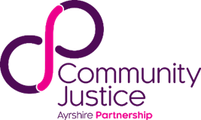
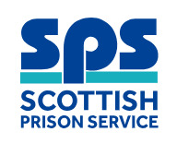

Housing | Call South Ayrshire Housing Options Team on 0300 123 0900 or out of hours call South Ayrshire Homelessness Standby Service on 0808 100 3151
Benefits / Money | Call DWP 0800 169 0345 or Information and Advice Team 0300 123 0900
Throughcare | Call Upside 0800 587 7263  or call Justice Social Work 01292 612395
GP Registration | Call NHS Inform 0800 22 44 88
Mental Health | Text ‘SAC’ to 85258 or Call Samaritans 116123
Foodbank | South Ayrshire Foodbank (Prestwick) call 07599 071114 or 07938 906636
Addictions | Call Rapid Access to Drug and Alcohol Recovery (RADAR) 01563 574237 Mon-Fri 9am-5pm, outside of these hours call NHS24 on 111
Peer Support | Call Peer Involvement Networking Group (P.I.N.G) Peer Support Group on 01292 289749
Advocacy | Call Circles Advocacy on 01292 264396
Health and Social Care | Call South Ayrshire Health and Social Care Partnership office on 0300 123 0900
Travel | Bus No 76 and 50 will take you into Kilmarnock Bus Station / Visit Travel Line website for route planner

For more information you can:

Visit the drop-in at Compass on 7-9 James Street, Ayr. You can get support here with things like housing, addictions, benefits, community support.
Their opening hours are Mon, Weds and Fri 10.00am-4.00pm, Tues and Thurs 11.00am - 7.00pm and Saturday 10.00am - 1.00pm.


See a full list of support services and more ways to get in touch online using the link below.
https://communityjusticeayrshire.org.uk/community-justice-directory/
Or scan QR code below.

My Appointments
Gate pick-up
Housing
Benefits and Money
Social Work
Addictions
Peer Support
Physical and Mental Health
Throughcare
Employability
Other

