Liberation Support

Contact Numbers and
Appointment Checklist

North Ayrshire (Men)

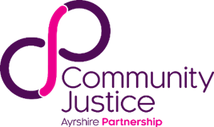
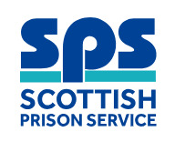

Housing | Call North Ayrshire Council 01294 314600 or Homeless out of hours 0800 019 6500
Benefits / Money | Call DWP 0800 169 0345 or NAC Money Smart 01294 310000 (option 1)
Throughcare | Call Upside 0800 587 7263 or Justice Social Work 01294 463924
GP Registration | Call NHS Inform 0800 22 44 88
Mental Health | Text ‘SUPPORTNA’ to 85258 or Call Samaritans 116123
Foodbank |   Scan for all locations or find in CJAP directory (info on next page)  For foodbank vouchers call North Ayrshire Health and Social Care Partnership 01294 310000
Addictions | Call North Ayrshire Drug and Alcohol Recovery Service (NADARS) 01294 476000
Peer Support | Making a Difference (MAD) Peer Support Group 01294 463924
Advocacy | Call VoiceAbility on 0300 303 1660
Health and Social Care | Call your local North Ayrshire Health and Social Care Partnership office  Arran – 01770 600742  Garnock Valley – 01505 684551  Irvine and Kilwinning – 01294 310300  North Coast – 01475 687592  Three Towns – 01294 310005
Travel | Bus No 76 and 50 will take you into Kilmarnock Bus Station / Visit Travel Line website for route planner

For more information you can:

Visit the drop-in for people recently released from prison at The Recovery Hub – Unit 2, Rivergate Shopping Centre, Irvine – next to Freckleton’s Café in the mall. It’s on every Wednesday 10.00am - 3.00pm and every Friday 10.00am-2.30pm. Or visit The Junction - Old Parish Church Hall, Irvine. It’s on every Thursday 10.00am – 3.00pm.

See a full list of support services and more ways to get in touch online using the link below.
https://communityjusticeayrshire.org.uk/community-justice-directory/
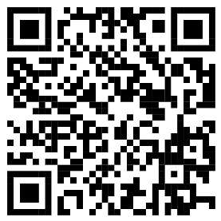
Or scan QR code below.

My Appointments
Gate pick-up
Housing
Benefits and Money
Social Work
Addictions
Peer Support
Physical and Mental Health
Throughcare
Employability
Other

