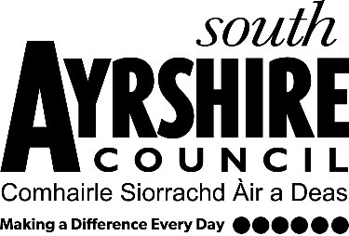
Equality and Diversity Forum
SAVE THE DATE
When?  Wednesday 23rd October 2024  At  2pm | What is it about?  South Ayrshire Council Equality and Diversity Forum would like to take this opportunity to invite you to attend this webinar which aims to raise awareness, understanding, and confidence in Community Justice. Delivered on behalf of the Community Justice Ayrshire Partnership.  Webinar Outline:  - What is Community Justice? An overview of the system, facts and figures, and the national aims for CJ.  - What is happening locally in Ayrshire through the Community Justice Ayrshire Partnership - our local plan, priorities and next steps.
Who are the webinars aimed at?
- Elected Members
- All staff

Booking a place:
To attend please email macy.biggar@south-ayrshire.gov.uk providing your name, job title, organisation and contact details.
Your place on the webinar(s) will be confirmed with a diary meeting request providing the online link to attend.
For further information please email equalities@south-ayrshire.gov.uk

